**Name: Muhammad Obaid Roll no.: CT-025(Section-A)**

**Lab Session 01**

EXERCISE

1. Write command to display all files having extension ‘docx’.

dir *.docx*

Output:-

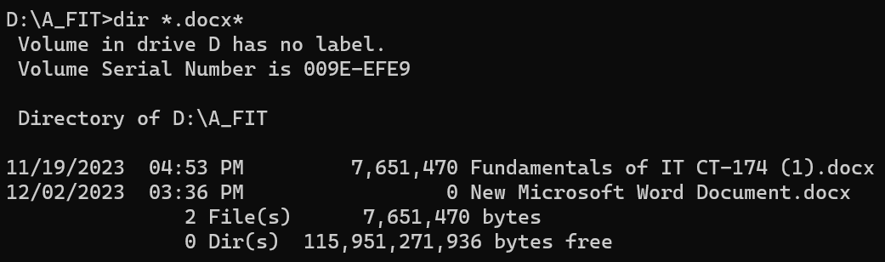

1. Write command to display all files of all types starting with letter ‘s’.

dir s* OR dir s*.*

Output:-

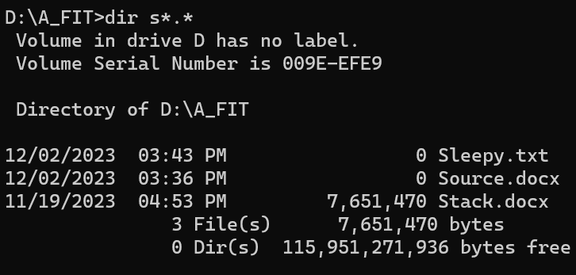

1. Write a command to copy the file *assignment* of type *docx* from the directory ‘ITC’ of drive D to drive F.

copy D:\ITC\assignment.docx F:\

Output: - (As I don’t have F-drive so used C)



1. Write a command to delete the directory as well as the files of the directory ‘*world*’ on drive E

del E:\world (First used to delete the contents of folder)

OR directly use rmdir /s /q E:\world

rd E:\world (Then to delete the empty folder)

Output: - (As I don’t have E-drive so used D)

Used dir to specify that directory is deleted

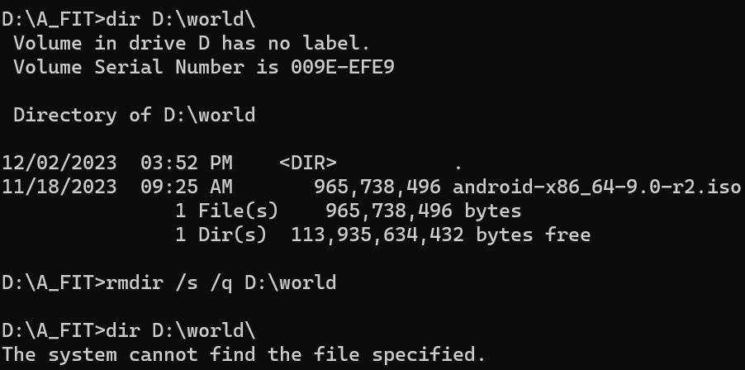

1. Write command to copy all the files beginning with ‘m’ and whose file names has a ‘txt’ extension from drive A to the ‘\document’ directory on drive C.

copy A:\m*.txt* C:\document\

Output: - (As I don’t have A-drive so used C)

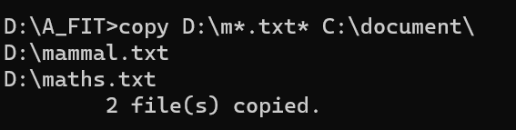

1. Write set of commands to create a directory ‘practical’ on drive F, and then move into it. Now list all files present in it, then go back to root drive F.

F:\> mkdir practical

F:\> cd practical

F:\practical> dir

F:\practical\ cd.. => F:\>

Output: - (As I don’t have F-drive so used D)

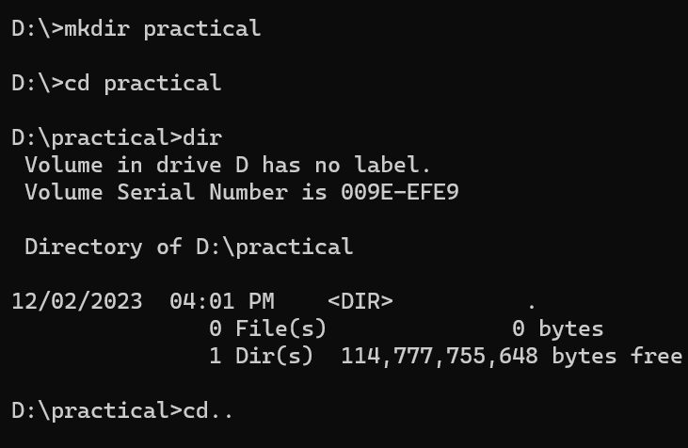

**Lab Session 02**

1. Write a command to change the command prompt to ‘Good Morning:\>’. Write another command using ‘$’ to switch back to the standard C prompt (C:\>).

**First Command:**  prompt Good Morning:\$g

**Second Command:**  Good Morning:\> prompt

Output:-

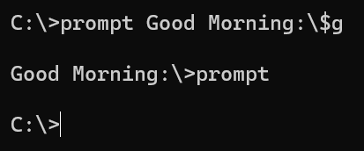

1. Write a command to set the system date to Jan 16th, 2018

First open cmd in administrator mode and then :- date 01-16-2018 in (MM-DD-YYYY) order

Output:-

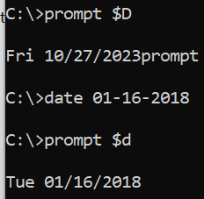

1. Make a batch file called first.bat, which includes commands to display directory listings of drive F, then remove a directory called “new” from the same drive. Do not switch into the drive.

@echo off

dir /b /s F:\

rmdir /s /q F:\new Now run this cmd by => call first.bat

Output:- (I used D-drive as don’t have F)

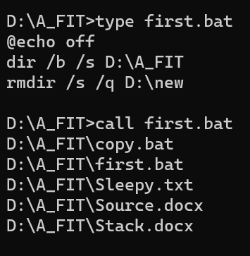

**Lab Session 03**

**EXERCISE**

1. Use Task Scheduler utility to daily prompt a Good Morning message on your screen at 9

a.m. List steps of accomplishing the above task.

As display a message command is deprecated (no longer supported) in newer version of windows so

Create a bat script file with following commands:-

@echo off

msg * "Good Morning!" (remember to put spaces in b/w)

Now open “Computer Management System” “Task Scheduler”. Create a basic task. Name and describe the

task accordingly

Set the “Trigger” as Daily on 9:00 A.M. Now click Next and choose to Run a Program. Select

the batch file that you made. Now click Finish to complete scheduling “Good Morning!”

Output:-

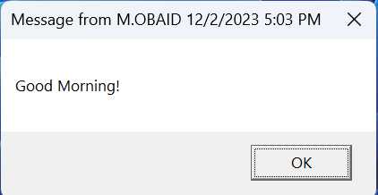

1. Your computer is giving warning for low disk space that means your containing the operating system software does not have enough space to ensure reliable system operations List various ways by which you can increase your disk space.

You can either delete unnecessary files/softwares or activate storage sense in Settings so that it disables the

unecessary apps/tasks that you don’t use OR if you can increase your ROM-capacity i.e. SSD or HDD or if you

have extra space so you can increase using “Disk management”. You can also shift your personal important

stuff to an external drive.